Curved Boundary Edge
# Source: AI Source: Provided by: [Data Path: Persons Table -> ID Column: 1, Name_En Column: Motasem Essam] -> From: [ChatGPT] on [7/25/2026]
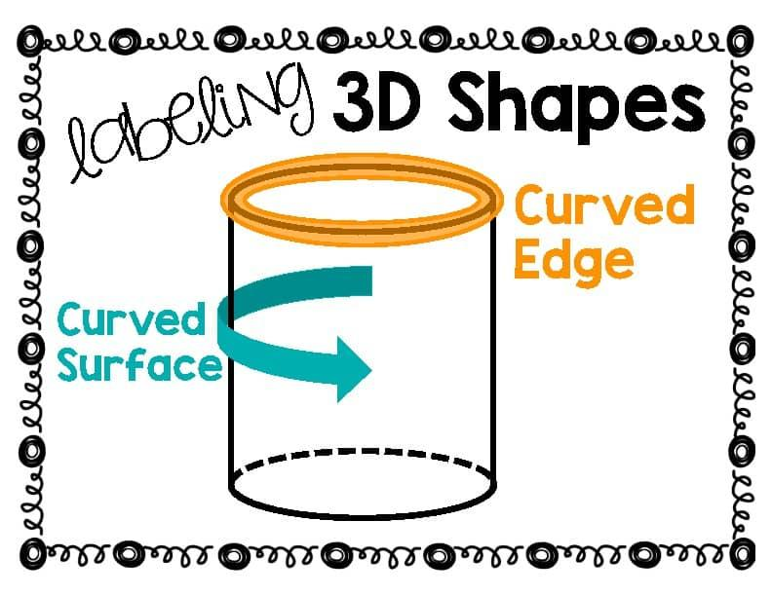
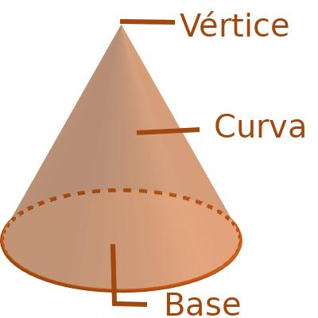
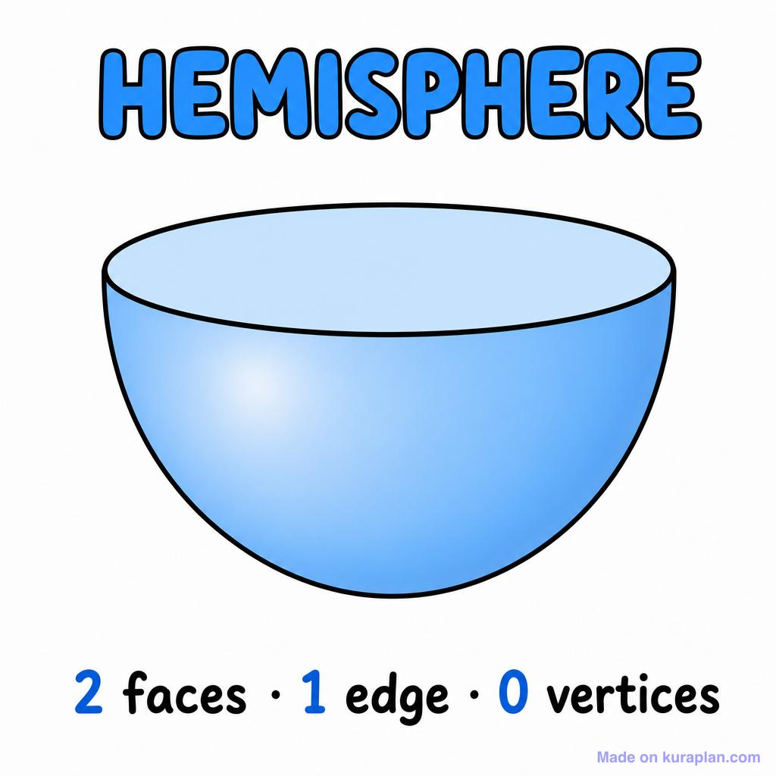

Definition
# Source: AI Source: Provided by: [Data Path: Persons Table -> ID Column: 1, Name_En Column: Motasem Essam] -> From: [ChatGPT] on [7/25/2026]
A curved boundary edge in solid geometry is a curved line that forms part of the boundary of a three-dimensional solid, often where a curved surface meets a flat surface or where two surface portions meet along a curved path.
Unlike a straight edge, which is a straight line segment, a curved boundary edge follows a curved path.
Examples include:
- The circular rim where the curved lateral surface of a cylinder meets its flat circular base.
- The circular edge where the curved surface of a cone meets its base.
- The circular rim of a hemisphere where its curved surface meets its flat circular face.
Important mathematical distinction: In elementary geometry, the term edge is most commonly used for the straight segments of polyhedra. For solids with curved surfaces, terms such as circular edge, curved rim, or boundary curve are often more precise.

Simple definition
# Source: AI Source: Provided by: [Data Path: Persons Table -> ID Column: 1, Name_En Column: Motasem Essam] -> From: [ChatGPT] on [7/25/2026]
A curved boundary edge is a curved line along the boundary of a solid, rather than a straight line segment.
For example, the circular rim around the bottom of a cone is a curved boundary edge because it follows a circle.

Classification tree
# Source: AI Source: Provided by: [Data Path: Persons Table -> ID Column: 1, Name_En Column: Motasem Essam] -> From: [ChatGPT] on [7/25/2026]
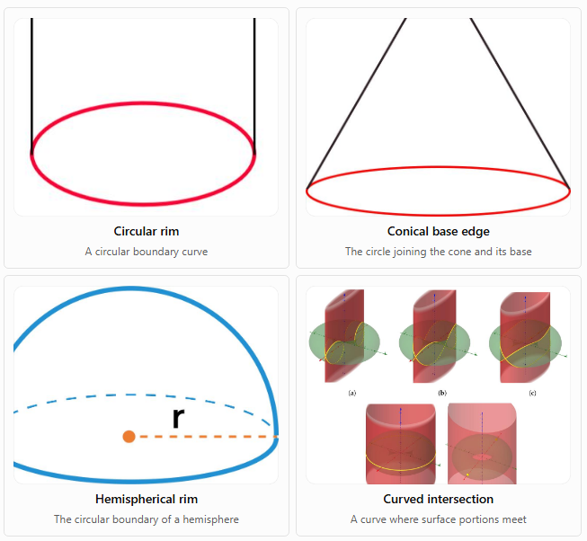
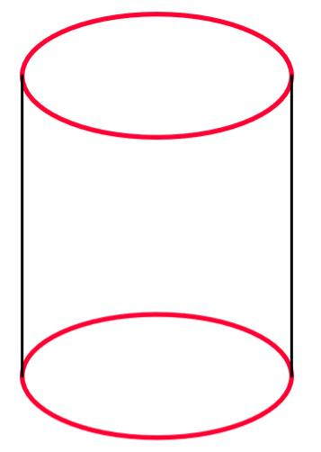
Circular rim
A circular boundary curve
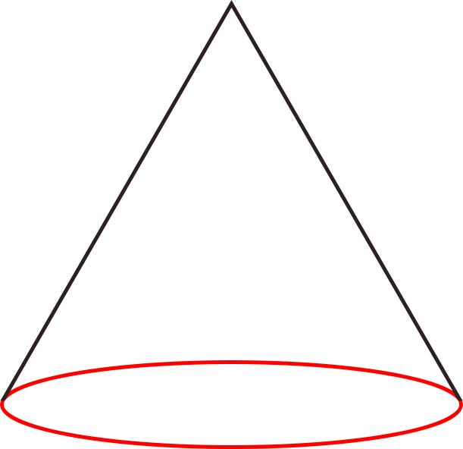
Conical base edge
The circle joining the cone and its base
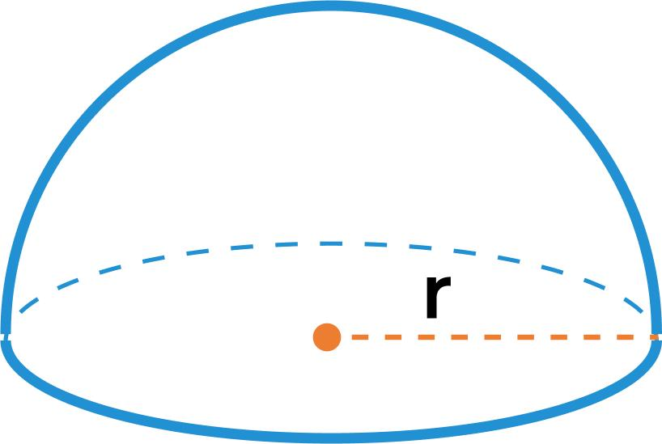
Hemispherical rim
The circular boundary of a hemisphere
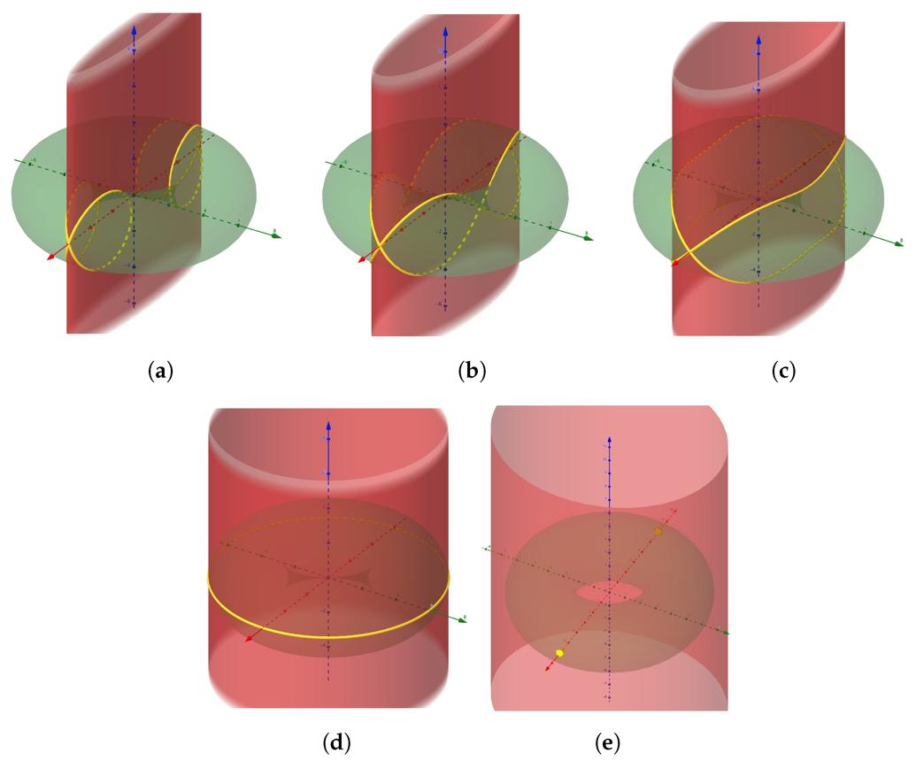
Curved intersection
A curve where surface portions meet
These are examples of curved boundary curves, not necessarily separate formal categories in every geometry curriculum.

Key characteristics
# Source: AI Source: Provided by: [Data Path: Persons Table -> ID Column: 1, Name_En Column: Motasem Essam] -> From: [ChatGPT] on [7/25/2026]
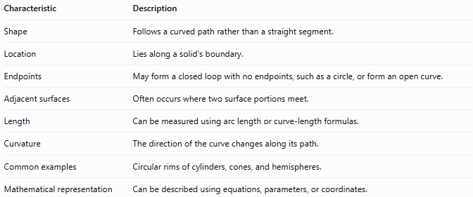
Characteristic | Description
Shape | Follows a curved path rather than a straight segment.
Location | Lies along a solid's boundary.
Endpoints | May form a closed loop with no endpoints, such as a circle, or form an open curve.
Adjacent surfaces | Often occurs where two surface portions meet.
Length | Can be measured using arc length or curve-length formulas.
Curvature | The direction of the curve changes along its path.
Common examples | Circular rims of cylinders, cones, and hemispheres.
Mathematical representation | Can be described using equations, parameters, or coordinates.

Geometric representation
# Source: AI Source: Provided by: [Data Path: Persons Table -> ID Column: 1, Name_En Column: Motasem Essam] -> From: [ChatGPT] on [7/25/2026]
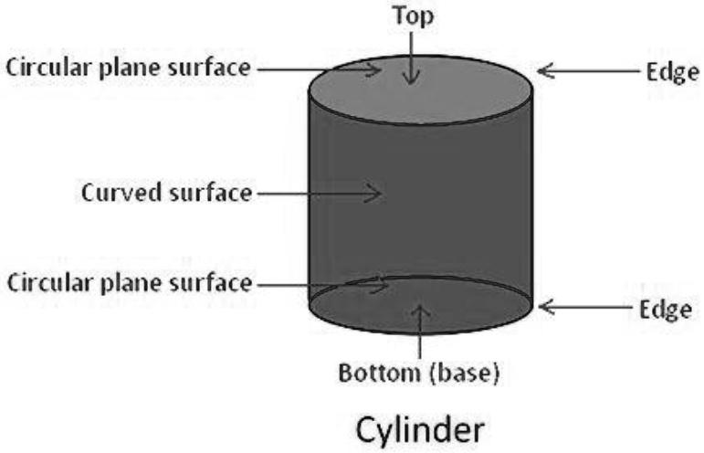
Consider a right circular cylinder.
Its curved lateral surface meets each flat circular base along a circular rim. Each rim is a curved boundary curve of the solid's surface structure.
The cylinder has two such circular rims:
- One at the top.
- One at the bottom.
The rims are circles, even though the cylinder's lateral surface is curved in a different way.
Other geometric examples

A. Cone
# Source: AI Source: Provided by: [Data Path: Persons Table -> ID Column: 1, Name_En Column: Motasem Essam] -> From: [ChatGPT] on [7/25/2026]
The circular rim connects the cone's curved lateral surface to its flat circular base.
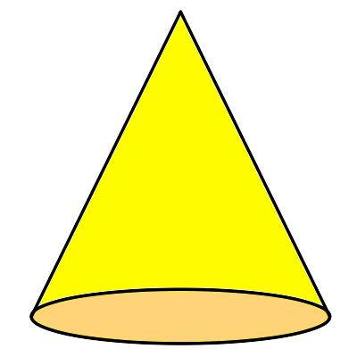

B. Hemisphere
# Source: AI Source: Provided by: [Data Path: Persons Table -> ID Column: 1, Name_En Column: Motasem Essam] -> From: [ChatGPT] on [7/25/2026]
The circular rim marks the boundary between the curved hemispherical surface and its flat circular face.
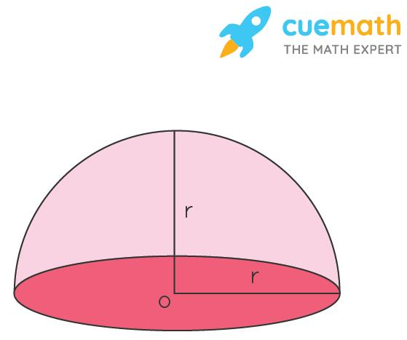

C. Intersecting curved surfaces
# Source: AI Source: Provided by: [Data Path: Persons Table -> ID Column: 1, Name_En Column: Motasem Essam] -> From: [ChatGPT] on [7/25/2026]
When curved surface portions meet, their intersection may form a curved boundary line. The precise curve depends on the surfaces involved.
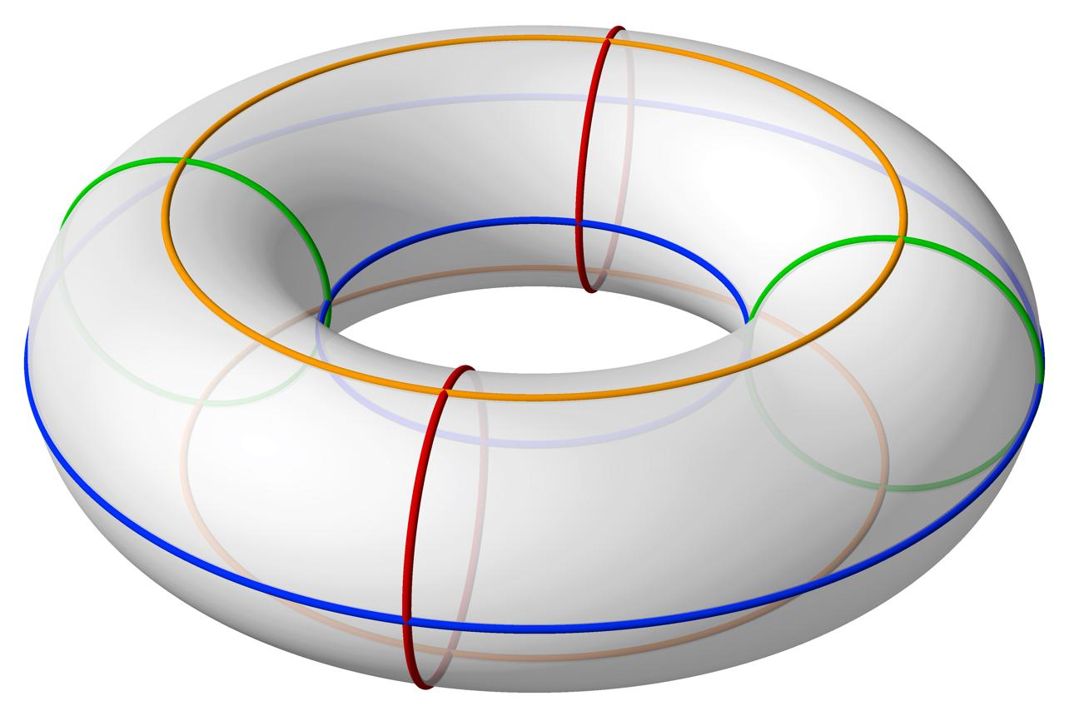

6. Mathematical representations

A. Equation of a circular boundary edge
# Source: AI Source: Provided by: [Data Path: Persons Table -> ID Column: 1, Name_En Column: Motasem Essam] -> From: [ChatGPT] on [7/25/2026]
For a circular rim of radius $r$ lying in the plane $z=h$, the boundary curve can be described by:
$$x^{2}+y^{2}=r^{2}, z=h$$
This describes a circle in three-dimensional space.
A parametric representation is:
$$x=r\cos{t}, \\ y=r\sin{t}, 0≤t≤2π \\ z=h,$$
Here, $t$ traces the entire circular boundary.

B. Length of a circular boundary edge
# Source: AI Source: Provided by: [Data Path: Persons Table -> ID Column: 1, Name_En Column: Motasem Essam] -> From: [ChatGPT] on [7/25/2026]
The circumference of a circular rim of radius $r$ is:
$$\boxed{L=2πr}$$
If the diameter is $d$, since $d=2r$,
$$\boxed{L=πd}$$

C. Arc length of a curved boundary
# Source: AI Source: Provided by: [Data Path: Persons Table -> ID Column: 1, Name_En Column: Motasem Essam] -> From: [ChatGPT] on [7/25/2026]
If the boundary curve is only part of a circle, its arc length is:
$$\boxed{L=rθ}$$
where $θ$ is the central angle measured in radians.
For an angle measured in degrees:
$$\boxed{L=\frac{θ}{{360}^{∘}} 2πr}$$

D. General curve length
# Source: AI Source: Provided by: [Data Path: Persons Table -> ID Column: 1, Name_En Column: Motasem Essam] -> From: [ChatGPT] on [7/25/2026]
For a smooth curve described parametrically by
$$r\left(t\right)=\left(x\left(t\right),y\left(t\right),z\left(t\right)\right), a≤t≤b,$$
its length is:
$$\boxed{L=\int_{a}^{b}{\sqrt{{\left[x'\left(t\right)\right]}^{2}+{\left[y'\left(t\right)\right]}^{2}+{\left[z'\left(t\right)\right]}^{2}}} dt}$$
This formula applies to many curved boundary curves, not only circles.

Worked examples
# Source: AI Source: Provided by: [Data Path: Persons Table -> ID Column: 1, Name_En Column: Motasem Essam] -> From: [ChatGPT] on [7/25/2026]
Example 1: Length of a cylinder's circular rim
A cylinder has a base radius of $7\text{ cm}$. Find the length of one circular boundary rim.
Step 1: Identify the radius.
$$r=7\text{ cm}$$
Step 2: Apply the circumference formula.
$$L=2πr$$
$$L=2π\left(7\right)=14π\text{ cm}$$
Answer:
$$\boxed{L≈43.98\text{ cm}}$$
The circular rim is approximately $43.98\text{ cm}$ long.
Example 2: Finding the length of a cone's base rim
A cone has a base diameter of $12\text{ cm}$. Find the length of its circular base boundary.
Step 1: Use the diameter formula.
$$L=πd$$
Step 2: Substitute $d=12$.
$$L=12π\text{ cm}$$
Answer:
$$\boxed{L≈37.70\text{ cm}}$$
Example 3: Finding an arc length
A circular boundary has a radius of $5\text{ cm}$, and a portion of the curve subtends an angle of ${90}^{∘}$. Find the length of that portion.
Step 1: Use the arc-length formula in degrees.
$$L=\frac{θ}{{360}^{∘}} 2πr$$
Step 2: Substitute the measurements.
$$L=\frac{{90}^{∘}}{{360}^{∘}} 2π\left(5\right)$$
$$L=\frac{14}{\left(10π\right)}=\frac{5π}{2}\text{ cm}$$
Answer:
$$\boxed{L≈7.85\text{ cm}}$$

Comparison with related concepts
# Source: AI Source: Provided by: [Data Path: Persons Table -> ID Column: 1, Name_En Column: Motasem Essam] -> From: [ChatGPT] on [7/25/2026]
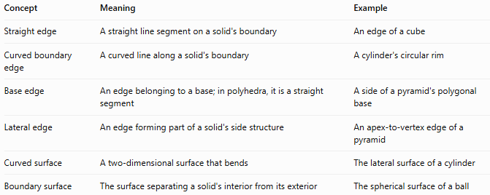
Concept | Meaning | Example
Straight edge | A straight line segment on a solid's boundary | An edge of a cube
Curved boundary edge | A curved line along a solid's boundary | A cylinder's circular rim
Base edge | An edge belonging to a base; in polyhedra, it is a straight segment | A side of a pyramid's polygonal base
Lateral edge | An edge forming part of a solid's side structure | An apex-to-vertex edge of a pyramid
Curved surface | A two-dimensional surface that bends | The lateral surface of a cylinder
Boundary surface | The surface separating a solid's interior from its exterior | The spherical surface of a ball
Important distinction: A curved boundary edge is one-dimensional, while a curved surface is two-dimensional. A circular rim is a curve; the cylindrical side surrounding it is a surface.

Applications
# Source: AI Source: Provided by: [Data Path: Persons Table -> ID Column: 1, Name_En Column: Motasem Essam] -> From: [ChatGPT] on [7/25/2026]
Curved boundary edges are useful in:
- Engineering: measuring circular rims, pipe openings, and curved joints.
- Architecture: describing the edges of domes, arches, and rounded structures.
- Manufacturing: specifying the circumference of container openings and cylindrical components.
- 3D modeling: representing the curves where surface patches meet.
- Geometry: calculating circumference, arc length, and surface intersections.
- Technical drawing: showing the outlines and curved transitions of three-dimensional objects.

Key points
# Source: AI Source: Provided by: [Data Path: Persons Table -> ID Column: 1, Name_En Column: Motasem Essam] -> From: [ChatGPT] on [7/25/2026]
- A curved boundary edge is a curved line along a solid's boundary.
- Circular rims are common examples in cylinders, cones, and hemispheres.
- A closed circular rim has no endpoints.
- Its length is calculated using the circumference formula $L=2πr$.
- A partial circular boundary can be measured using the arc-length formula.
- A curved boundary edge is different from a curved surface.
- In formal polyhedral geometry, edges are straight segments; for curved solids, boundary curve or curved rim may be more precise terminology.

Conclusion
# Source: AI Source: Provided by: [Data Path: Persons Table -> ID Column: 1, Name_En Column: Motasem Essam] -> From: [ChatGPT] on [7/25/2026]
A curved boundary edge in solid geometry describes a curved line along the boundary of a three-dimensional solid, such as the circular rim of a cylinder, cone, or hemisphere. Understanding these curves helps distinguish edges from surfaces and provides the foundation for calculating circumferences, arc lengths, and geometric intersections.

